

Students Name:………………………………………

SPECIALIST MATHEMATICS UNITS 3 & 4

TRIAL EXAMINATION 1

2018

Reading Time: 15 minutes
Writing time: 1 hour

Instructions to students
This exam consists of 10 questions.
All questions should be answered in the spaces provided.
There is a total of 40 marks available.
The marks allocated to each of the questions are indicated throughout.
Students may not bring any notes or calculators into the exam.
Where more than one mark is allocated to a question, appropriate working must be shown.
An exact answer is required to a question unless otherwise specified.
Unless otherwise indicated, diagrams in this exam are not drawn to scale.
The acceleration due to gravity should be taken to have magnitude 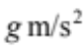where 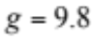
Formula sheets can be found on pages 11 – 13 of this exam.

This paper has been prepared independently of the Victorian Curriculum and Assessment Authority to provide additional exam preparation for students. Although references have been reproduced with permission of the Victorian Curriculum and Assessment Authority the publication is in no way connected with or endorsed by the Victorian Curriculum and Assessment Authority.

© THE HEFFERNAN GROUP 2018
This Trial Exam is licensed on a non transferable basis to the purchasing school. It may be copied by the school which has purchased it. This license does not permit distribution or copying of this Trial Exam by any other party.
Question 1 (2 marks)

Evaluate 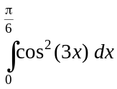.

Question 2 (3 marks)

Given the relation 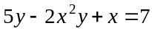, find the equation of the tangent to the graph of this relation at the point 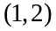.

Question 3 (3 marks)

The weight of eggs produced at a free range farm varies normally with a mean of 68 g and a standard deviation of 4 g.
These eggs are sold in boxes which contain 16 eggs.
Find, correct to four decimal places, the approximate probability that the mean weight of an egg in a randomly selected box is less than 65 g.

Question 4 (3 marks)

Find the value of a given that is a solution to the equation 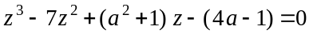, where a is a real constant.

Question 5 (5 marks)

Consider the three vectors 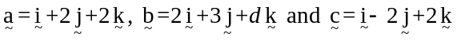 where d is a real constant.

- Find a unit vector in the direction of . 1 mark

- Find the vector resolute of perpendicular to . 2 marks

- Find the value of d if the three vectors are linearly dependent. 2 marks

Question 6 (4 marks)

Solve the differential equation

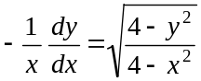, given that 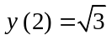.

Express your answer in the form 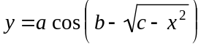 where 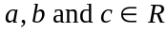.

Question 7 (3 marks)

The velocity v, in ms⁻¹, of a 5 kg mass is given by 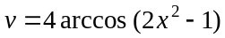 where x, in metres, is its displacement from the origin and .
Find the net force F, in newtons, acting on the mass in terms of x.

Question 8 (5 marks)

Let 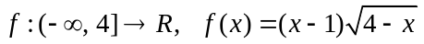.

S represents the region enclosed by the graph of f and the x-axis.

- Find the area of S. 3 marks

- The region S is rotated around the x-axis to form a solid of revolution. Find the volume of this solid of revolution. 2 marks

Question 9 (4 marks)

A curve is defined parametrically by 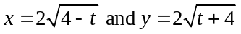.
Find the length of this curve from .

Question 10 (8 marks)

- Sketch the graph of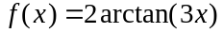 on the set of axes below.
Label any asymptotes with their equations. 2 marks

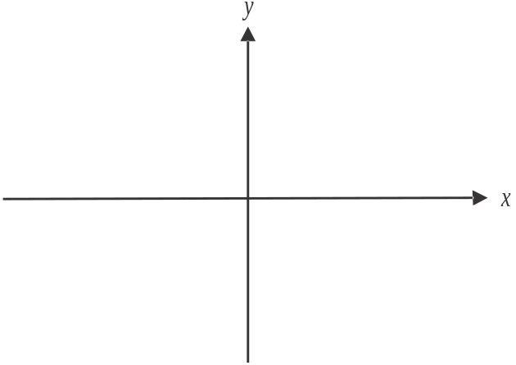

- Find the rule and the domain of the inverse function 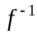. 2 marks

c. Find 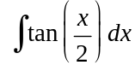. 1 mark

d. Hence find the area enclosed by the graph of f, the x-axis and the line 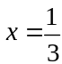. 3 marks

Specialist Mathematics Formulas

Mensuration

area of a trapezium | 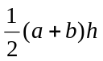
curved surface area of a cylinder | 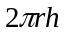
volume of a cylinder | 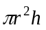
volume of a cone | 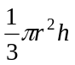
volume of a pyramid | 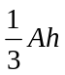
volume of a sphere | 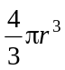
area of a triangle | 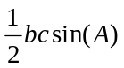
sine rule | 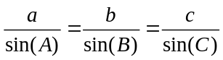
cosine rule | 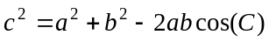

Circular functions

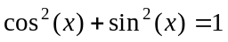
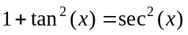 | 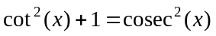
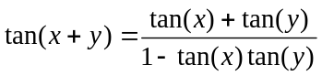 | 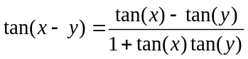
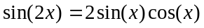 | 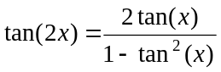

Mathematics Formula Sheets reproduced by permission; © VCAA 2017. The VCAA does not endorse or make any warranties regarding this study resource. Current and past VCAA VCE® exams and related content can be accessed directly at www.vcaa.vic.edu.au

Circular functions – continued

Function | 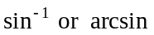 | 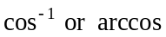 | 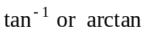
Domain | 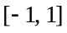
Range | 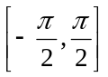 | 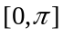 | 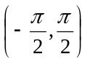

Algebra (complex numbers)

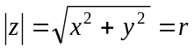 | 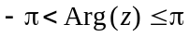
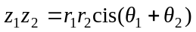 | 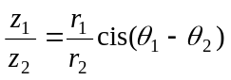
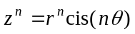 (de Moivre’s theorem)

Probability and statistics

for random variables X and Y | 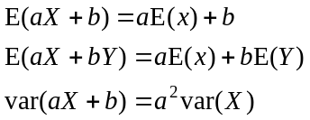
for independent random variables X and Y | 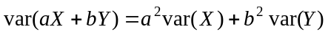
approximate confidence interval for | 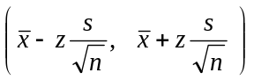
distribution of sample mean 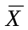 | 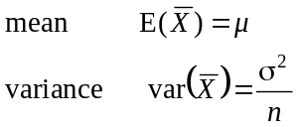

Calculus
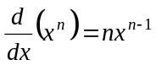 | 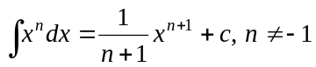
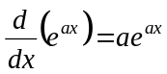 | 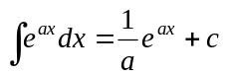
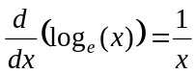 | 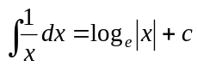
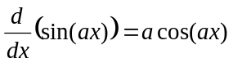 | 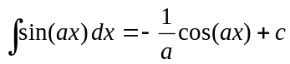
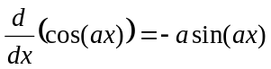 | 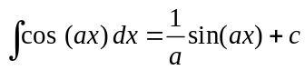
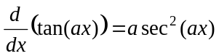 | 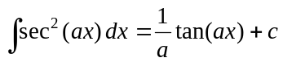
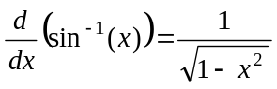 | 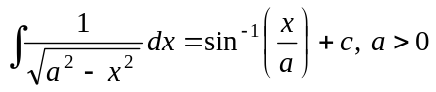
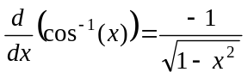 | 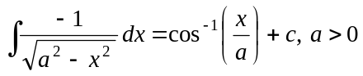
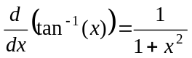 | 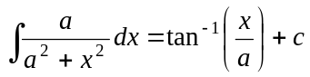
 | 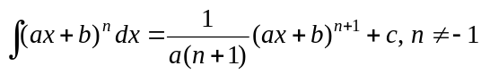
 | 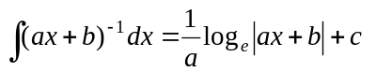
product rule | 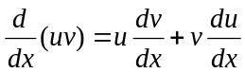
quotient rule | 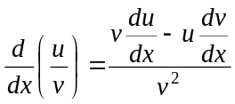
chain rule | 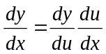
Euler’s method | 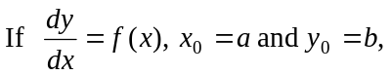
acceleration | 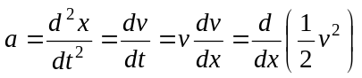
arc length | 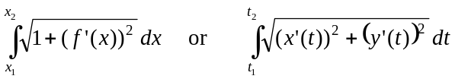

Vectors in two and three dimensions Mechanics
momentum | 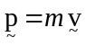
equation of motion | 